|  |  |  |  |  |  |  |  |  |
| --- | --- | --- | --- | --- | --- | --- | --- | --- |
|  | * | **r** | **a** | **b** | **b** | **b** | **i** | **t** |
| * | 0 | 0 | 0 | 0 | 0 | 0 | 0 | 0 |
| **r** | 0 | **1** | **0** | **0** | **0** | **0** | **0** | **0** |
| **a** | 0 | 0 | **1** | **0** | **0** | **0** | **0** | **0** |
| **b** | 0 | 0 | 0 | **1** | **1** | **1** | **0** | **0** |
| **b** | 0 | 0 | 0 | 0 | **1** | **1** | **0** | **0** |
| **i** | 0 | 0 | 0 | 0 | 0 | 0 | **1** | **0** |
| **t** | 0 | 0 | 0 | 0 | 0 | 0 | 0 | **1** |

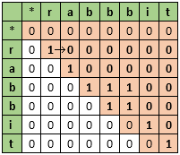

第一次，填表：判断T[j] 是否 等于 S[i] 。1代表相同，0代表不同

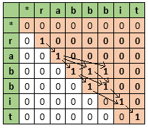

第二次，查表：从T[1]到T[end] 有几种走法（走法：从1到1，走也是有条件的，不能走到白色的方块；有几种走法即有几个子序列）

计算有几种走法可以用递归，但效率较低，可用循环。

|  |  |  |  |  |  |  |  |  |
| --- | --- | --- | --- | --- | --- | --- | --- | --- |
|  | * | **r** | **a** | **b** | **b** | **b** | **i** | **t** |
| * | 3 | 0 | 1 | 1 | 1 | 1 | 1 | 0 |
| **r** | 0 | **3** | **0** | **0** | **0** | **0** | **0** | **0** |
| **a** | 0 | 0 | **3** | **0** | **0** | **0** | **0** | **0** |
| **b** | 0 | 0 | 0 | **2** | **1** | **1** | **0** | **0** |
| **b** | 0 | 0 | 0 | 0 | **1** | **1** | **0** | **0** |
| **i** | 0 | 0 | 0 | 0 | 0 | 0 | **1** | **0** |
| **t** | 0 | 0 | 0 | 0 | 0 | 0 | 0 | **1** |